NCRC1203A Lab 4 – NAT
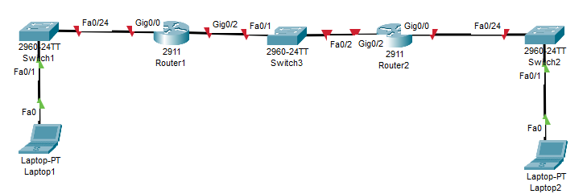
Figure 1 - Lab 4 Layout
Lab - Configure NAT for IPv4
Device | Interface | IP Address | Subnet Mask
R1 | G0/0 | 192.168.1.1 | 255.255.255.0
R1 | G0/2 | 200.100.50.1 | 255.255.255.0
R2 | G0/0 | 192.168.3.1 | 255.255.255.0
R2 | G0/2 | 200.100.50.254 | 255.255.255.0
S1 | VLAN 1 | 192.168.1.2 | 255.255.255.0
S2 | VLAN 1 | 192.168.3.2 | 255.255.255.0
Laptop1 | NIC | 192.168.1.11 | 255.255.255.0
Laptop2 | NIC | 192.168.3.33 | 255.255.255.0

Background / Scenario
Network Address Translation (NAT) is when a network device, such as a Cisco router, assigns a public address to host devices inside a private network. The main reason to use NAT is to reduce the number of public IP addresses that an organization uses because the number of available IPv4 public addresses is limited.

In this lab, you will configure various types of NAT. You will test, view, and verify that the translations are taking place, and you will interpret the NAT/PAT statistics to monitor the process.
Note: Ensure that the routers and switches have been erased and have no startup configurations. If you are unsure contact your instructor. If you are prompted to enter initial configuration mode when booting the router or switch, choose NO.
One student is responsible for R1 and SW1, the other student is responsible for R2 and SW2. Share the 3rd switch responsibilities.

Instructions

Part 1: Build the Network and Configure Basic Device Settings

Cable the network as shown in the topology.
Attach the devices as shown in the topology diagram and cable as necessary.

Configure basic settings for each router and switch. No config for SW3 is required
Open configuration window
      - Assign the device names to the devices. Please name the routers yourinitialsRX (where the X is a 1 or 2). Do the same for SW1 and SW2
      - Configure interface IP addresses as specified in the table above.
      - Configure a default route to R2 from R1.
      - Save the running configuration to the startup configuration file.
      - Verify that you can ping all devices.
After the configuration was done we did the pings to test connectivity.

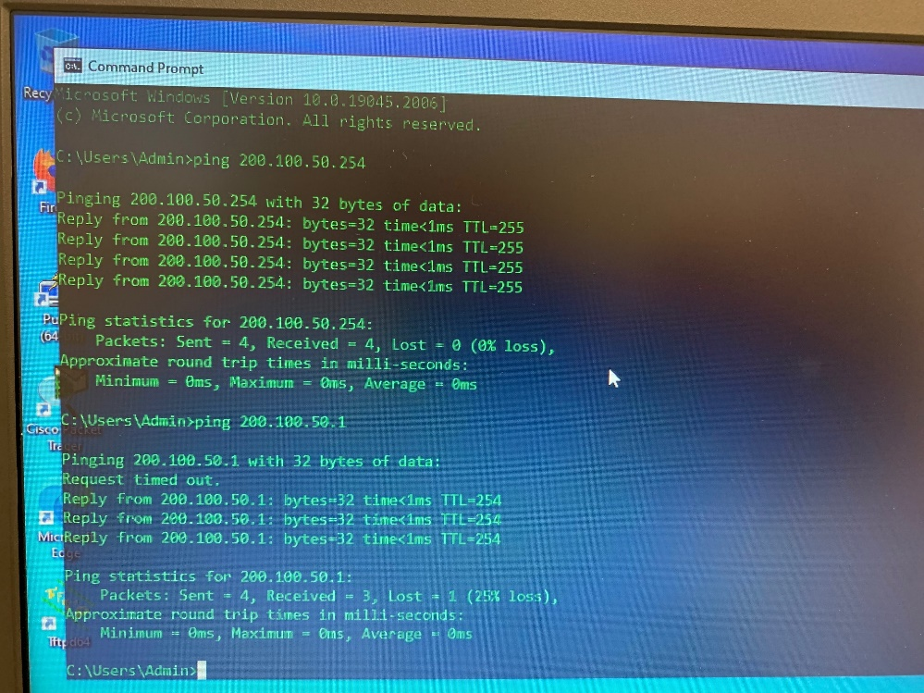

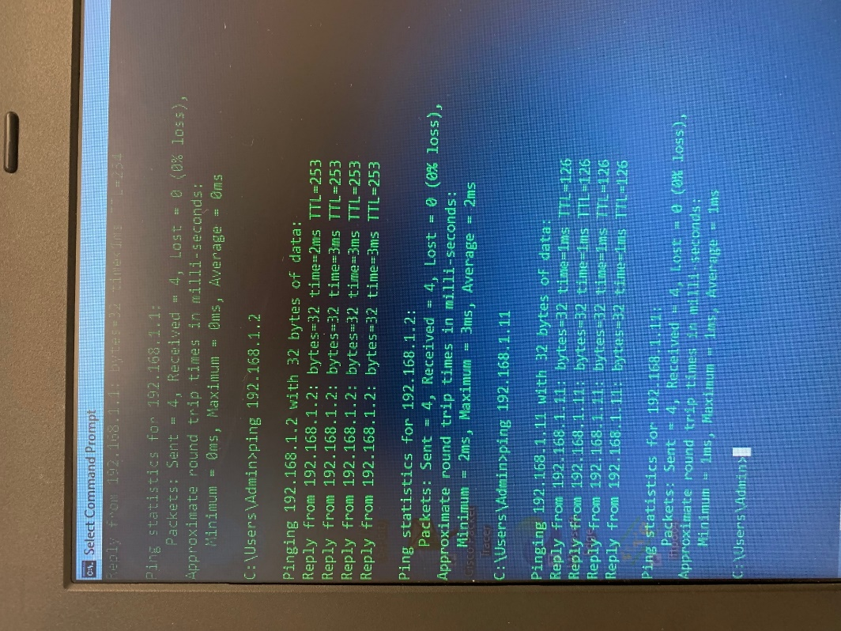

Part 2: Configure and verify Static NAT for IPv4
You will configure static NAT so that your switch is directly reachable from the internet. SW1 will be reachable via the address 200.100.50.12. SW2 will be reachable via the address 200.100.50.22
Note: The configuration you will complete does not follow recommended practices for internet-connected gateways. This lab completely omits what would be standard security practices to focus on the successful configuration of static NAT. In a production environment, careful coordination between the network infrastructure and security teams would be fundamental to supporting this requirement.

Step 1: On R1and R2, clear any current translations and statistics.
Open configuration window
R1# clear ip nat translation *
R1# clear ip nat statistics

Step 2: On your router, configure the NAT commands required to statically map an inside address to an outside address. You will create a static mapping of your switch to use the following IP Addresses: SW1 will be reachable via the address 200.100.50.12. SW2 will be reachable via the address 200.100.50.22
Example: to configure a static mapping between 192.168.1.11 (inside) and 209.165.200.199 (outside) use the following command:
R1(config)# ip nat inside source static 192.168.1.111 209.165.200.199
Then go to the interfaces which are to be the inside and outside
R1(config)#int g0/0
R1(config-if)#ip nat inside
R1config-if)#int g0/2
R1config-if)#ip nat outside

Paste the commands you used to configure the static mapping here:
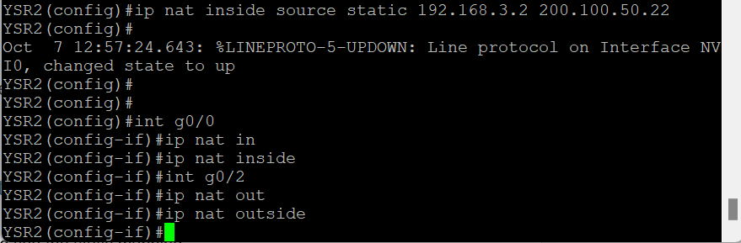

Step 3 - Test and Verify the configuration.
      - Let’s verify the Static NAT is working. On R1, display the NAT table on R1 with the command show ip nat translations, and you should see the static mapping.
Run the command show ip nat translations and paste the output here:
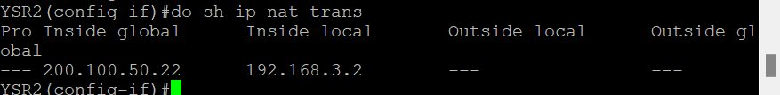

      - The translation table shows the static translation is in effect. Verify this by pinging from R1 to SW2’s translated address, and from R2 to SW1’s translated address. The pings should work.
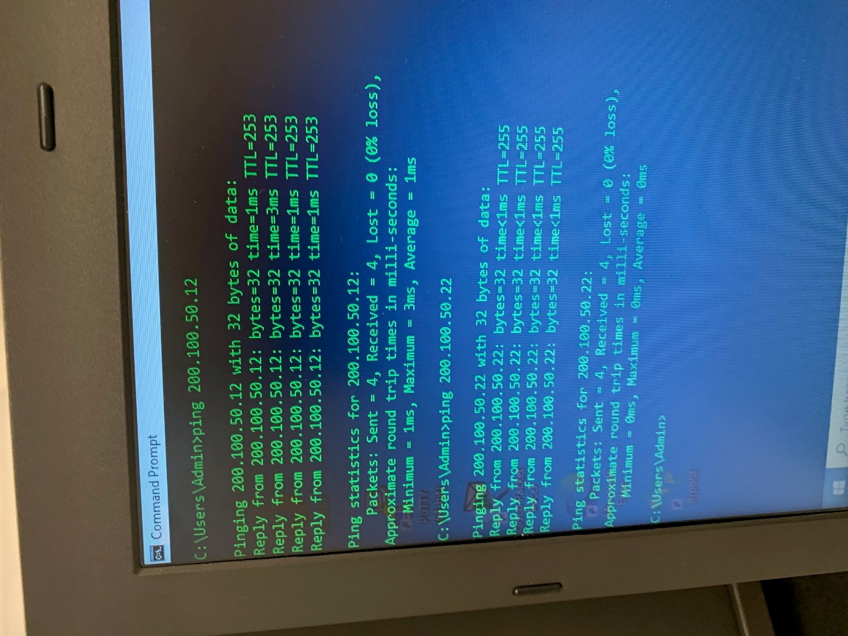

      - On your router, display the NAT table on R1 with the command show ip nat translations, and you should see the static mapping and the port-level translation for the inbound pings. Paste your output here (overwriting my sample below)
R1# show ip nat translations
Pro Inside global Inside local Outside local Outside global
--- 209.165.200.229 192.168.1.2 --- ---
icmp 209.165.200.229:3 192.168.1.2:3 209.165.200.225:3 209.165.200.225:3
Total number of translations: 2
This validates that the Static NAT is working.
Congratulations, you have setup Static NAT.

On R1and R2, clear any current translations and statistics.
Open configuration window
R1# clear ip nat translation *
R1# clear ip nat statistics

Part 3: Configure and verify NAT for IPv4
In Part 3, you will configure and verify NAT for IPv4.

Step 1- Configure NAT on R1 and R2 using a pool of three addresses for each router:

R1 will use 200.100.50.30-32. R2 will use 200.100.50.40-42.
Open configuration window
      - Configure a simple access list that defines what hosts will be allowed for translation. We want the networks your laptops are on to use your assigned pool. In this case, all devices on the LAN are eligible for translation.
R1(config)# access-list 1 permit 192.168.1.0 0.0.0.255

R2 (config)#
      - Create the NAT pool and give it a name and a range of addresses to use. Follow this example:
R1(config)# ip nat pool PUBLIC_ACCESS 209.165.200.226 209.165.200.228 netmask 255.255.255.248
Note: The netmask parameter is not an IP address delimiter. It should be the correct subnet mask for the assigned addresses, even if you are not using all the subnet addresses in the pool.
      - Configure the translation, associating the ACL and Pool to the translation process.
R1(config)# ip nat inside source list 1 pool PUBLIC_ACCESS

Note: Three very important points. First, the word ‘inside’ is critical to the operation of this kind of NAT. If you omit it, NAT will not work. Second, the list number is the ACL number configured in a previous step. Third, the pool name is case-sensitive.

Step 2 - Test and Verify the configuration.
      - From Laptop 1, ping the G0/2 interface of R2. From Laptop 2, ping the G0/2 interface of R1.
      - On your router, display the NAT table with the command show ip nat translations. Paste the output here

Questions:
What was the inside local address of your laptop translated to?
My PC2 was translated to 200.100.50.40 (inside global)here.

What type of NAT address is the translated address?
The translated address for PC2 is an inside global address.

Type your answers here.
      - Change the address of your switch to .1.5 and 3.5, respectively. From SW1, ping the G0/2 interface of R2. From SW2, ping the G0/2 interface of R1. Display the NAT table on your router with the command show ip nat translations. Paste that output here:
I did many pings
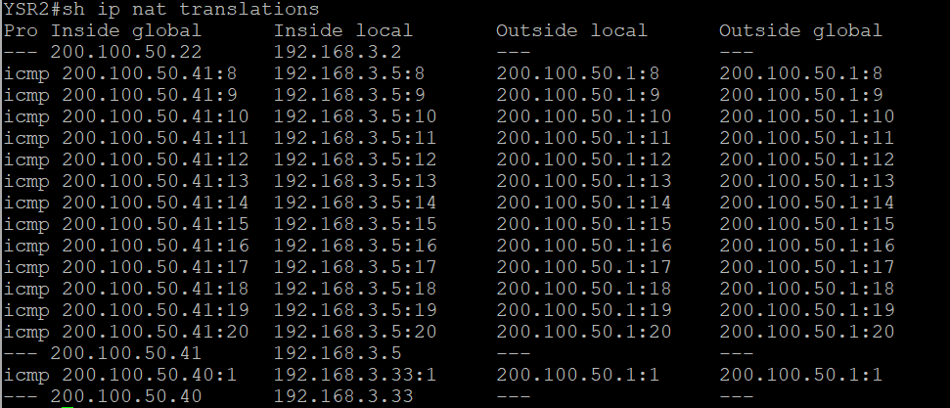

      - Notice that the previous translation for your laptop is still in the table. What would happen if two other devices tried to ping?
The next would have the inside global as 200.100.50.42 and the last would be without any global address since there were only 3 available.

      - Issue the command show ip nat translations verbose and tell me how long the translations are good for. Paste the output here to support your answer.

For example, 200.100.50.40 has the time left of 23h 54min and 8 sec.

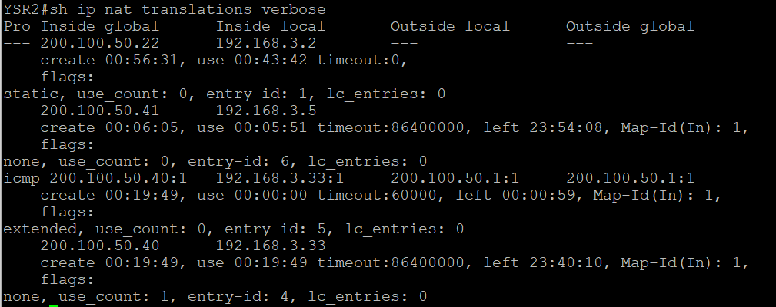

      - Given that the pool is limited to three addresses, NAT to a pool of addresses is inadequate for our application. Clear the NAT translations and statistics, and we will move on to PAT.
R1# clear ip nat translations *
R1# clear ip nat statistics

Part 4: Configure and verify PAT for IPv4
In Part 4, you will configure replace NAT with PAT using an interface.

Step 1 - Remove the translation on R1.
Open configuration window
The components of an Address Translation configuration are basically the same; something (an access-list) to identify addresses eligible to be translated, an optionally configured pool of addresses to translate them to, and the commands necessary to identify the inside and outside interfaces. Our access-list (access-list 1) is still correct for the network scenario, so it is unnecessary to recreate it. We are not going to use a pool of addresses, therefore we will remove references to the pool.
To get started in Part 4, remove the command that ties the ACL and pool together.
R1(config)# no ip nat inside source list 1 pool PUBLIC_ACCESS
Also, remove the pool of addresses:
R1(config)# no ip nat pool PUBLIC_ACCESS

Step 2: Add the PAT overload command by specifying the outside interface.
Add the PAT command that will cause overload to the outside interface. Example on R1:
R1(config)# ip nat inside source list 1 interface g0/2 overload

PAT is now in operation.

Test and Verify the configuration.
      - Let’s verify PAT is working. From Laptop1, ping G0/2 interface on R2. From Laptop2, ping G0/2 interface on R1. Display your NAT table with the command show ip nat translations. Paste the output here:

Questions:
What was the inside local address of your Laptop translated to?
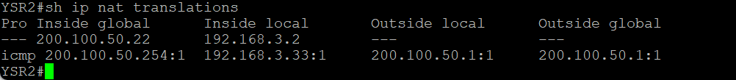
What type of NAT address is the translated address?
The ip address is 192.168.3.33 (laptop 2) was translated to 200.100.50.254

What is different about the output of the show ip nat translations command from the earlier NAT exercise?
The earlier NAT had a range of IPs while the PAT the IP was the one for int g0/2.
answers here.
      - From SW1, ping the G0/2 interface of R2. From SW2, ping the G0/2 interface of R1. Display the NAT table on your router with the command show ip nat translations. Paste that output here:
I did many pings
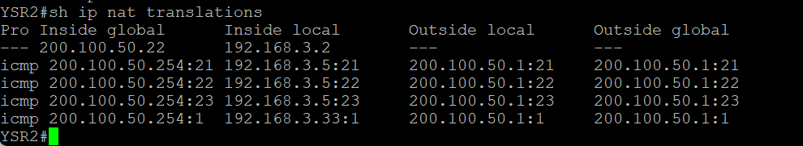

Notice that there is only one translation again. Send the ping once more, and quickly go back to the router and issue the command show ip nat translations verbose and you will see what happened.
What did the translation timeout drop to?
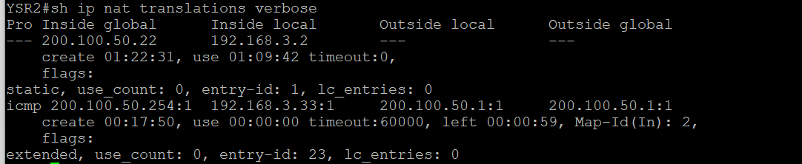
59 seconds

      - Ping from both your laptop and your switch at the same time. Examine the NAT Table again. Question: how does the router keep track of what replies go where?
It creates a port number for each connection.
Type your answers he

When you have completed the lab, submit it to the proper DropBox as yourname_Lab4.Docx

Before leaving: Run the command write erase on your router and your switch. Power off and pack up your laptops and pods neatly.

